Welcome to Emmanuel Catholic Primary School OSHC

Dear 2021 Outside School Hours Care Families.

We are so excited to welcome you to our early year’s specific program, Emmanuel Catholic Primary School Outside School Hours Care Service, located on Baxter Drive, Mt Pleasant, Queensland, 4740.

The service aims to provide leisure based, social learning experiences for children in Outside School Hours Care through the dedication of our qualified educators so that we can support each child’s spiritual, physical, social, intellectual and emotional abilities.

We would like to share some information regarding the commencement of the year:

- Contacting the OSHC service is vital if your child if away sick, gone home from school during the day, or is attending the OSHC on a day they usually do not attend. Fees and Booking procedures are outlined in the Family Handbook please read this information.
- Our OSHC service operates under the Regulatory Authority-The Department of Education and Care and therefore we abide by the National Education and Care Services Act and Law. Please take the time to visit the Framework document for OSHC website - My Time Our Place: https://www.education.gov.au/my-time-our-place

- Enrolment Information
Please return the following documents to finalise your child’s enrolment (if you have not done so already):
- Your child’s Enrolment Form
- Your child’s Immunisation documents
- Birth Certificate or confirmation of date of birth on a recognised State or Federal Government document
- Direct Debit form
- Any health care information to accompany the child’s enrolment. e.g. action plan, health plan.

Upon return of these completed forms your child will be entered into the OSHC system, the OSHC will submit the request for your child to be linked to the Child Care Subsidy System, however you must log into your mygov a/c and confirm the enrolment before any subsidy will be paid by the government subsidy scheme. Until this confirmation is made full fees will be charged on any attendances.

- OSHC Fees

After School Care Routine: $24.50 per child per session
After School Care Casual: $25.00
Vacation Care: $53.00
Late Fee $17 for every 15 mins or part thereof per family

- Hours of Operation

After school | 3:00pm | 6:00pm
Vacation Care | 7.00am | 6.00pm

- Programming
Our OSHC is committed to providing a quality program where every child’s physical, emotional, spiritual and social needs are met in a safe, caring and supportive environment.
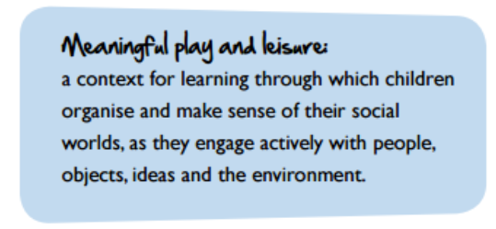
Our Service delivers a Program, which aligns with the Australian Government’s National Quality Framework “My Time Our Place”. The Framework aims to maximise learning outcomes for children who participate in OSHC programs and offers guidance to educators on specific areas to support children in their learning and development Please take the time to visit the National Quality Framework “My Time Our Place” website https://www.acecqa.gov.au/sites/default/files/2018-02/educators_my_time_our_place.pdf to view the framework that guides our program.

- OSHC Staff
We would also like to introduce you to our team:
Nominated Supervisor | Geraldine Rostirolla
OSHC Coordinator | Nicole Klease
OSHC Educator | Jacinta Semple
OSHC Educator | Thea Crathorne
OSHC Educator | Debbie Faix
OSHC Educator | Sandali DeSoysa
OSHC Educator | Kendall Smith
OSHC Educator | Maryanne Vella
OSHC Educator | Imogen White

- Nutrition
Our service endeavours to provide a variety of nutritious food such as:
- plenty of vegetables, beans and lentils
- fruit
- breads, cereals, rice, pasta, noodles (mostly wholegrain), and other grains like oats and barley
- milk, yoghurt and cheese
We ask for suggestions from children and families into the planning our menus.
Fresh water is available at the service at all times.

- Orientation

The orientation may include information about the following: participation of families in the service’s program, sign in/out procedures, fee payment options, location of the parent area, location of relevant documents, introduction of educators, and the family code of conduct and parent concern procedures. Families are encouraged to speak with our OSHC Coordinator for further information.

Please do not hesitate to contact me if you have any further questions
via email enm_oshc@rok.catholic.edu.au
Service Mobile Phone Number: 0429 311 579
Kind regards
Emmanuel OSHC

