26 March 2020

CANCELLED
School Mass

Whole School
Friday Assemblies

Choral Festival

ANZAC Day March

All Mackay District
School Sports

POSTPONED
Swimming Carnival
And Blue Water Lagoon Excursion

School Disco

Emmanuel Children’s Mass

Stations of the Cross

LAST DAY OF TERM
Friday 3 April

Dear Parents,
The Lenten period is an important season in the life of the Church. We are given permission to ‘start again’ and to embrace the mystery of life in our quest to be better people. Lent is about both self and communal improvement and is a journey towards a closer relationship with others and with our God.
At Emmanuel, however, we never encourage students to be perfect, only to come to school to give their best and to work with everyone (not just our friends). Working with others doesn’t automatically mean that we will get along famously or have perfect days every day. In fact, conflict is part of daily life and is a healthy aspect of any community. Effective people resolve conflict in ways that protect relationships, honour feelings and lead to a resolution. They neither avoid conflict nor do they use power to dominate others or to ‘win’.
Emmanuel is a learning community and as such we are interested in supporting students to learn better ways to resolve conflict and think about their emotions. This includes learning conflict resolution processes and systems so that peaceful resolutions can be reached.
One process recommended by parenting expert Michael Grose that is both easy to learn and highly effective is the Face-Up conflict resolution process that is a variation on some common processes already in use.
The steps involved in the Face-Up process:
- Safety first: To ensure safety and integrity it is important that both children are calm. Give them time and some help to regain control if they are angry or upset.
- Feeling second: Using I-messages children tell each other how they feel about the situation. “I feel awful when you don’t share your toys. I really feel like losing it because it is not fair.” Focus on the feelings and don’t let it get into recriminations or accusations.
- Repeat third: Sometimes this process is enough to get a resolution or at least an apology. Repeat this procedure if necessary so both children feel they have been heard.
- Resolve fourth: State the problem as you see it or as children identify it. Sometimes children just want to state their case and they will make their own suggestion about resolving it. “You can play with my old toys but I don’t want you playing with my new toys for a while. They’re special.” “Okay.”

- Make-up fifth: An apology or an agreement is often enough, however sometimes damage may need to be repaired or a follow-up talk from a parent about better behaviour may be appropriate.

In our journey towards Easter, working towards peaceful resolutions of conflict is one practical way of enhancing both personal and community relationships.

Wishing you God’s blessings throughout the Lenten season,

Geraldine Rostirolla
Principal
Religious Education

HE NEEDED ME – A REFLECTION

A nurse escorted a tired, anxious young man to the bed side of an elderly man. "Your son is here," she whispered to the patient. She had to repeat the words several times before the patient's eyes opened. He was heavily sedated because of the pain of his heart attack and he dimly saw the young man standing outside the oxygen tent.

He reached out his hand and the young man tightly wrapped his fingers around it, squeezing a message of encouragement. The nurse brought a chair next to the bedside. All through the night the young man sat holding the old man’s hand, and offering gentle words of hope. The dying man said nothing as he held tightly to his son.

As dawn approached, the patient died. The young man placed on the bed the lifeless hand he had been holding, and then he went to notify the nurse.

While the nurse did what was necessary, the young man waited. When she had finished her task, the nurse began to offer words of sympathy to the young man.

But he interrupted her. "No, he was not my father. I have never seen him before in my life."

"Then why didn't you say something when I took you to him?" asked the nurse.

He replied, "I also knew he needed his son, and his son just wasn't here. When I realized he was too sick to tell whether or not I was his son, I knew how much he needed me..."

(Author Unknown)

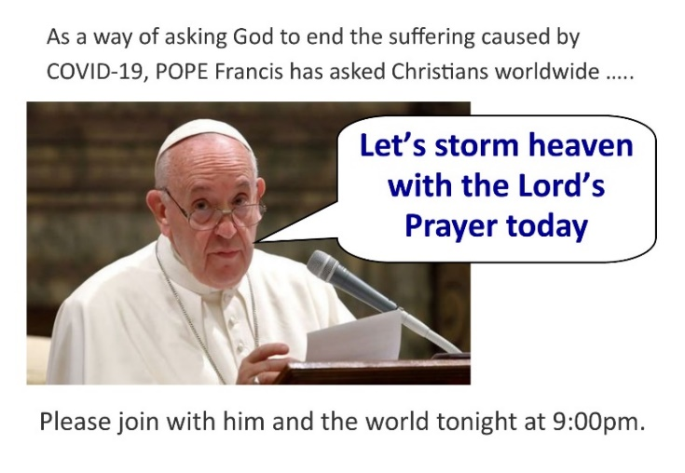
Our Father,
who art in heaven,
hallowed be thy name;
thy kingdom come;
thy will be done on earth as it is in heaven.
Give us this day our daily bread;
and forgive us our trespasses
as we forgive those who trespass against us;
and lead us not into temptation,
but deliver us from evil.

Amen
TIME TO SWITCH OFF
Tomorrow we will take part in World Earth Hour’s school event. Lights, screens and all devices will be turned off in classrooms between 2:00pm and 3:00pm. In joining this action we promote the care of our planet, reduce the use of energy and walk in solidarity with our brothers and sisters around the world who do not have electricity. This is in line with the Pope’s encyclical Laudato Si and Catholic Social Teachings.

You might like to consider participating in Saturday night’s Earth Hour from 8:30pm. Together we can make a difference.

Easter Raffle DRAWN TOMORROW

Last chance for tickets in our Easter Raffle. They are great value at a cost of 50 cents each or three for $1.00. Our Year Six Leaders will be selling the tickets before school and at lunchtime each day. All money raised will be forwarded to the missions.

A big thank you to the Emmanuel Staff for donating all the goodies for this multi-draw raffle.

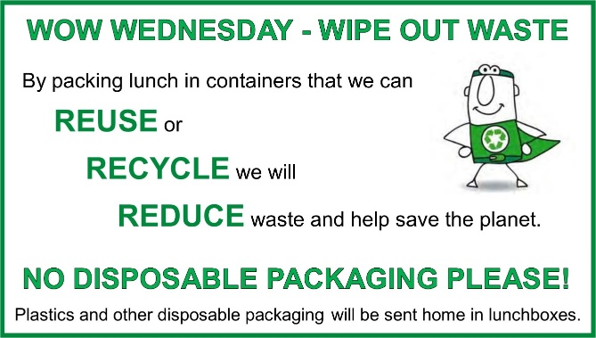

This Lent we have been answering God’s call to love others and to care for His beautiful world by supporting WOW Wednesdays. Together we are making a difference. Keep up the great effort everyone.

MJR AND CORONAVIRUS

In these uncertain times, it is important to remember that we are all in this together and we need to support and encourage each other. Being a WEST person is a great start.

Welcome with a wave, nod or foot tap. Encourage with positive words and phrases (written or verbal) or give a smile or a thumbs up. With people being a little more on edge than usual, the willingness to say sorry is important, as is taking the time to say thanks (for the little things as well as the big things).

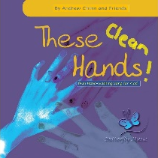
WASH YOUR HANDS

Andrew Chinn's classic song 'These Hands' has been revised to help kids have fun washing their hands. Enjoy singing along.

https://www.youtube.com/watch?v=qtuHxlC0I7M&feature=youtu.be
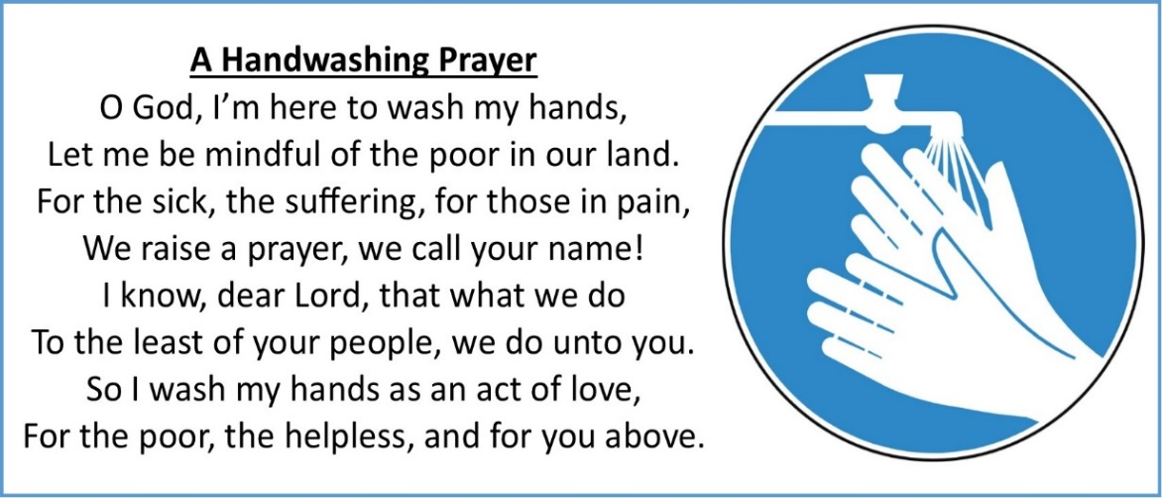
Prayer Source: https://catholicsentinel.org/Content/Faith-Spirituality/Living-Faith/Article/A-Handwashing-Prayer-/4/29/39582
DIOCESAN RESPONSE TO CORONAVIRUS - MASSES AND LITURGIES

http://rok.catholic.net.au/news-events/coronavirus-covid-19/

As previously advertised Bishop Michael McCarthy has suspended ALL PUBLIC MASSES in the Rockhampton Diocese until further notice. This will include all Holy Week ceremonies.

Share in Daily Mass from St Joseph’s Cathedral @ https://www.youtube.com/channel/UCQeYD6B2cSvFb4zqStn_Brg

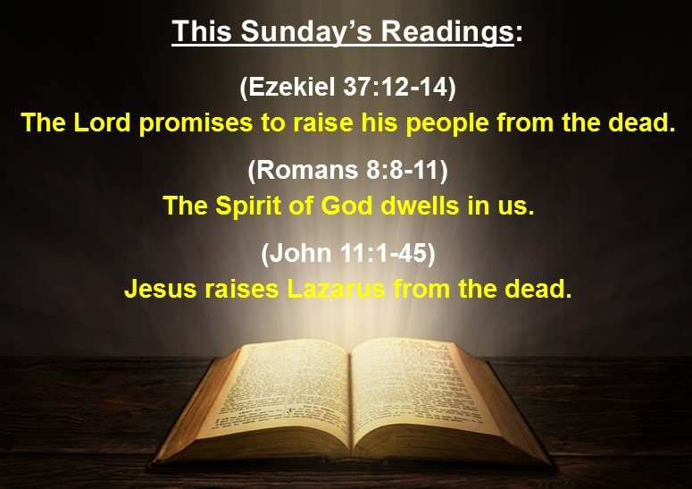

Scriptural context – Jesus wept
‘Jesus wept’ is the shortest verse in the New Testament. Just two little words carry a world of emotion and speak volumes about Jesus. Pope Leo I used this verse to highlight the two natures of Jesus, pointing out that in his humanity, Jesus wept for the death of his friend, but in his divinity Jesus raised Lazarus to life. Lazarus and his sisters were close friends of Jesus and Jesus is clearly emotional about the death and its effect on Martha and Mary. That Jesus is about to restore Lazarus to life does not deny the grief and mourning at Lazarus’ death.

Living the Gospel – Unbind him, let him go free
To see a man bound up for burial suddenly come walking from his tomb must have been an unnerving experience to say the least. However, Jesus calmly commands the astonished onlookers to ‘unbind him, let him go free’. These words speak to us today as we come to the end of the Lenten season and approach the celebration of Easter. What are the things that ‘bind’ us? From what do we need to be released so that we may ‘go free’? Are they bindings placed by ourselves or others? What will it take to be unbound?
Gospel Focus – Death for Life
The gospel writer paints the picture that Jesus is fully conscious of the implications of his return to Judea. As the events of the Passion unfold through this gospel, the reader has a very clear impression in their mind that if Jesus had not come to Judea; had not raised Lazarus; then he would not have been arrested and crucified. The reader is also drawn into the revelation that the sacrifice of Jesus was not solely for Lazarus but rather for all humanity. This realisation leads the reader to the ultimate humbling conclusion that if the sacrifice of Jesus was for people then the reader themselves is also the recipient of that sacrifice.

© Creative Ministry Resources Pty Ltd

Consideration begins by noticing what people need and thinking about how your actions could affect them. When you are considerate, you care about how others feel. You acknowledge that other people are just as important as you are. You treat them with kindness and respect and do little things to bring happiness to them. You are the friend that you would like to have.

“Blessed is one who adds to the happiness of another.” (Unknown)

Noeleen Kliese
Assistant Principal Religious Education

Curriculum Corner

LEARNING FROM HOME
As Term One draws to a close, classrooms are experiencing an increasing rate of absenteeism due to the current COVID-19 Social Distancing rules and other restrictions being placed on everyone. To support the continuation of student learning within the classroom and home environment, teachers have been working very hard to create a “Learning from Home” platform for all families to access.
At the beginning of Term Two, a Google Classroom will be made available to all year levels so that students learning from home can access teaching and learning from home.
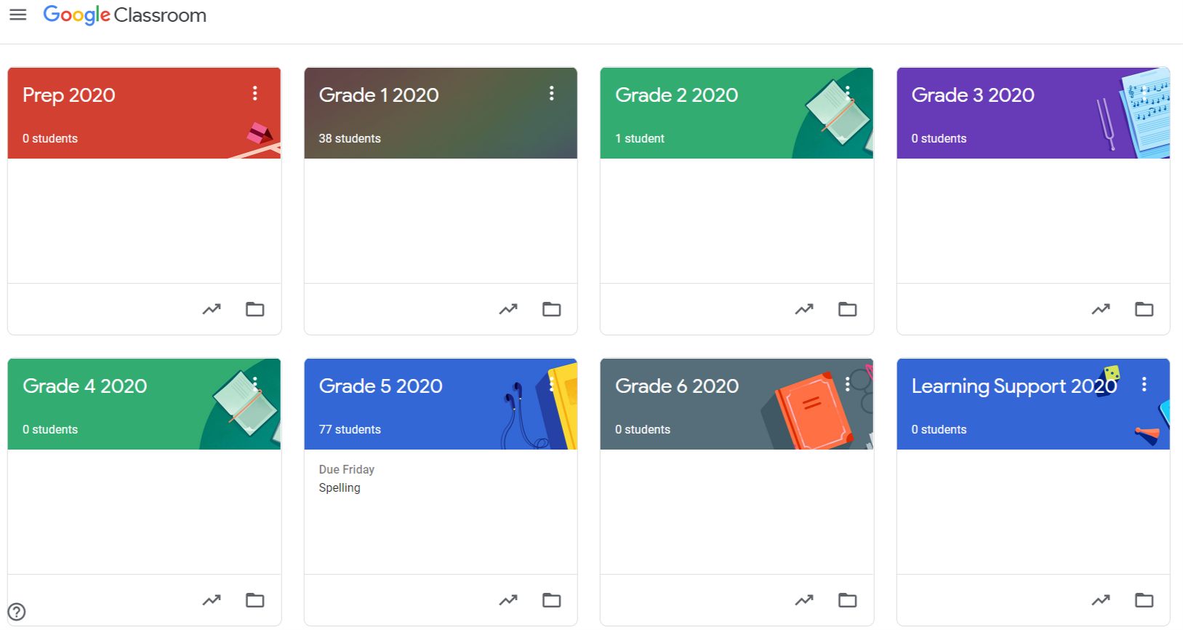
To ensure all families can access our online tools, there are a couple of tasks which will be required of families between now and the end of term. The first is to inform your classroom teacher via email, if your child is unable to access the internet, or has no access to a digital device to use as a learning tool. Please email your child’s classroom teacher no later than Monday 30 March.
Please be assured that provisions will be made for families who have limited technology and internet access by way of paper-based learning packs. Teachers will pass details of these families to the office for provisions to be made, and you will be contacted next week.
Over the past week teachers have been working with students to ensure they are familiar with log in details and routines. Children will not be expected to remember all of these details, they will be provided with hard copies prior to the end of term. For families whose children are remaining at home and not attending school, details will be emailed by your child’s classroom teacher by 3.00pm Monday 30 March. If at anytime details are misplaced or issues occur with log in information please email the classroom teacher and you will be provided with your details once again.
It is important prior to the end of this term that teachers are notified if your child/ren are unable to access their google classroom page. Please follow the instructions below to log your child in from a home device. Please notify your child’s classroom teacher by Thursday 2 April if you are unable to access Google classroom via a home device.
ACCESSING GOOGLE CLASSROOMS
When logging on for the first time:
1. Search ‘Google Classroom’ and click on the first search result
2. Click on the coloured letter icon in the top right corner and click ‘add another account’
3. Log in with your child’s Google account (If they do not have one click Add Account)
- First, enter their email as follows, ensuring you replace ‘username’ with your child’s individual username:
username@rokstu.catholic.edu.au
4. Click continue
5. Select student
6. Click the + icon in the top right corner
If your child has not previously joined their class the following box will appear…
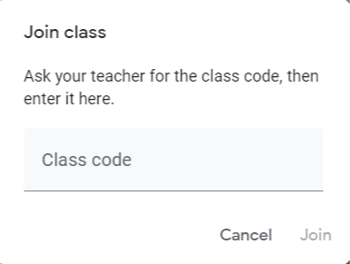
7. Type in your child’s class code:
Prep code: ezevz6n
Year 1 code: an2i6lo
Year 2 code: sbbaksr
Year 3 code: i5cugox
Year 4 code: xdsr2mk
Year 5 code: 32ajmrh
Year 6 code: ojwzojr
8. Click ‘join’
If your child has previously joined their class the Google Classroom will appear. Below is an example of the Year 2 Classroom. In this case click on the classroom and you can begin!
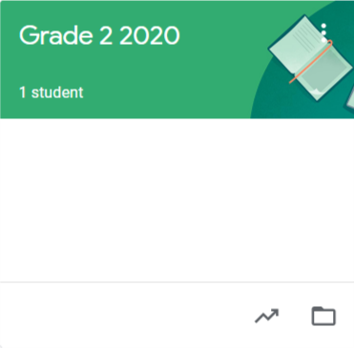
9. When visiting the Google Classroom the tabs at the top are:
Stream - like a feed of information, messages and updates (similar to your facebook feed). Whenever something is added to your classroom a new message will appear on this page.
Classwork - where you will be able to access all learning activities, games, worksheets, assignments etc.
Accessing Google Classroom video: https://m.youtube.com/watch?v=5kOVPBP9NYU
Over the next few weeks, teachers, students and parents will be learning together even more so than in our regular environment. As the last couple of weeks have proven, circumstances are changing rapidly. Please be assured that our goal is to ensure that productive, purposeful and engaging learning can continue if students are unable to come to school. We will endeavour to keep you informed and keep learning accessible for all students either face to face; online or digital; or via paper copies.
During this time, the most effective method of communication from parents to teachers is email. Teachers cannot always answer their emails as promptly as you may expect so I ask that you email myself janine_refalo@rok.catholic.edu.au if you require further assistance.
PLEASE REFRAIN FROM USING THIS SITE UNTIL FURTHER DIRECTION FROM YOUR CLASSROOM TEACHER. IT IS ANTICIPATED THAT WE WILL BE INTERACTING VIA OUR GOOGLE CLASSROOMS NEXT WEEK, HOWEVER WE STILL HAVE SOME REFINEMENTS TO MAKE, AND WE APPRECIATE YOUR SUPPORT AND PATIENCE. TEACHERS WILL NOTIFY YOU WHEN STUDENTS ARE REQUIRED TO COMPLETE ACTIVITIES IN THEIR GOOGLE CLASSROOM.

EFFECTIVE HAND HYGIENE IS VITAL
As the coronavirus (COVID-19) continues to evolve, it is important to remember that effective hand and sneeze/cough hygiene is the best defence against viruses and can help prevent the spread of illness.
Lead by example and encourage your children to:
- wash their hands regularly with soap and water, before and after eating, and after going to the toilet
- use alcohol-based hand sanitiser if soap is not available
- cover coughs and sneezes with a tissue or the inside of their elbow
- dispose of tissues in the bin immediately
- if they’re unwell, stay at home and avoid contact with others such as touching, kissing or hugging.
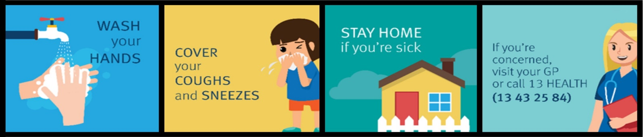
Check out effective handwashing @ youtube.com/watch?v=NpmB80pWUsk&feature=youtu.be

PREP ENROLMENTS 2021
Prep enrolment details for 2021 are NOW required from our existing families. If you have a child due to commence Prep next year born between July 1, 2015 and June 30, 2016 please complete an online enrolment form available from the school website - https://www.ecps.qld.edu.au/application-for-enrolment.html by Friday 3 April. It is essential that we have our current families accounted for so as to determine how many positions may be offered to new families seeking enrolment. If you have any queries or concerns, please contact the office. Interviews will commence at a date to be advised.

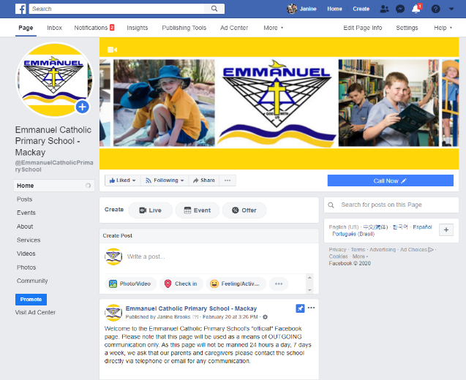
SCHOOL FACEBOOK PAGE

As previously advertised, Emmanuel’s official Facebook page is now Emmanuel Catholic Primary School – Mackay. We will no longer be using the Emmanuel P&F Facebook page.

There is another unofficial Emmanuel page which has no affiliation with the school and is not manned by Emmanuel staff.

Please look for the logo (pictured) so that you are “liking” the correct page. The link is attached for your convenience.
https://www.facebook.com/EmmanuelCatholicPrimarySchool/

Amanda McDonald
Assistant Principal Administration

Principal’s Awards

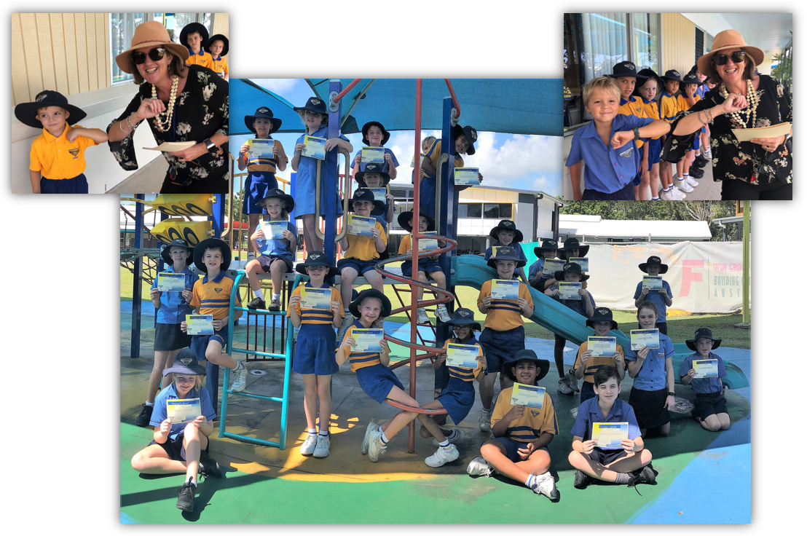
Congratulations to the following students who were awarded Principal’s Awards last week
Year 6: Xavier Chivers, Hayley Goldburg, Lleyton Scott, Ava Northam
Year 5: Blake Tongue, Artaya Ridley, Zali Herring, Abby McCreadie, Tua Chow, Bindert Hovinga
Year 4: Tahlia Harris-Swift, Lillian Wiechers, Oscar Lewis, Janice Joseph, Jake Ryan
Year 3: Finn Bow, Lexie Adamson, Eva Show, Alexis Muscat
Year 2: Flynn Armstrong, Charli van der Linden, Amber Holmstrom, Lucas Hooper, Ruby Johnson
Year 1: Charlotte Clugston, Michael Swan, Xavier Drummond, Siale Hovinga
Prep: Chayse Crisp, Caleb James, Connor Armstrong

Tuckshop News

Tuckshop Roster – Week Ten
Monday 30 March | HELP WANTED
Tuesday 31 March | Rachel Worth
Wednesday 1 April | Asinate Waqa
Thursday 2 April | Paul Johnson
Friday 3 April | Peta Drury  Meggs Weissman  Katie Murphy
Due to end of term approaching, some items on the menu may become unavailable and will be taken offline. Please discuss a second choice with your child in the event that an item is not available. We would like to thank all of our very generous volunteers for their help over the term and look forward to seeing you again when school resumes
Angie McGowan/Carly Nicholas
Tuckshop
