19 March 2020

**CANCELLED**

School Mass

Whole School

Friday Assemblies

Choral Festival

ANZAC Day March

All Mackay District

School Sports

**POSTPONED**

Swimming Carnival

And Blue Water Lagoon Excursion

School Disco

**LAST DAY OF TERM ONE**

Friday 3 April

Dear Parents,

Families have changed a lot in recent years and there are more and more time pressures on parents and children. But spending time together as a family is very important to children. A good relationship with their parents helps children to feel safe and secure. It also means they’re more likely to be happier, healthier and to get along better with others. Children and young people lead very full lives – school, friends, sport, music, the list can be endless. Young people today have many wonderful opportunities, but they need time to explore things in depth. When they are involved in too many different things, they sacrifice breadth for depth. Creativity is making something out of nothing and it takes time for that to happen.

Most child experts would agree that after-class activities can be a positive force in young people’s lives, but they would also argue that too many activities can put children at risk. Balance is the key. As parents, we might be tempted or pressured to believe that we are not being “good” parents if our children aren’t involved in all kinds of activities.

However, children need time to read, write, think, dream, draw, fantasise and explore special interests. They need time to “hang-out” with friends, ride their bikes, have water balloon fights and build cubby houses out of cardboard boxes and other bits and pieces. Such activities promote self-awareness by helping children clarify who they are and what they are truly interested in. Children who are involved in too many programmed activities may have too little time for these experiments of self-discovery.

It’s possible that parents think their children will grow up and remember all the wonderful activities they were involved in; whereas, it’s probable that children will think how exhausted they were trying to cope with multiple activities and how their parents were constantly yelling at them to hurry up and get ready for the next activity.

What children need most are relationships, not activities. Building meaningful relationships with our children allows us to “enjoy the landscape together” and not simply to be chauffeurs.

REFLECTION

“You are the bows from which your children as living arrows are sent forth.

The archer sees the mark upon the path of the infinite,

and He bends you with His might, that His arrows may go swift and far.

Let your bending in the Archer’s hand be for gladness;

For even as He loves the arrow that flies,

So He loves also the bow that is stable.”

[Kahlil Gibran](http://www.goodreads.com/author/show/6466154.Kahlil_Gibran), [*The Prophet*](http://www.goodreads.com/work/quotes/2938937)

Wishing you God’s blessings throughout the Lenten Season,

Geraldine Rostirolla

(Principal)



**THE ALPHABET PRAYER – A REFLECTION**

A shepherd boy was watching his sheep one Sunday morning when he heard the bells of a nearby church ringing. As he watched the people making their way to Mass, he thought to himself, "*I would like to talk to God too, but, what do I say*?"

He had never learned to pray and did not know a single prayer. So, on bended knee, he began to recite the alphabet. He repeated this ‘prayer’ several times. A man passing by heard the boy's voice and saw him kneeling with his hands joined and his eyes closed.

He interrupted the boy. "*What are you doing, young man*?" he asked.

The boy replied, "*I am praying sir*."

The man seemed surprised and said, "*But why are you saying the alphabet*?"

The boy explained, "*I don't know any prayers, sir, but I want God to take care of me, and to help me care for my sheep……and so I thought, if I said the alphabet, He could put the letters together into words, and He would know all that I need, want and should say*!"

The man smiled and said, "*Yes! You are right! God certainly will!*" and he went on to church knowing full well that he had heard the finest sermon he could possibly hear that day.

(Author Unknown)

**PRAYING THIS LENT**

Prayer is a dialogue. It can be talking to God, [listening to God](http://www.bibleverse411.com/Bible-Verses-About-Listening-to-God.html), praising God, or thanking God.  It can be silent, spoken, sung, confessed, or written. Prayer is being with God, being aware of God, sitting in the presence of God. It develops our relationship with the God who calls us to relationship. Prayer is a gift from God.

Pope Francis tells us that praying does not have to be difficult, that you can pray anytime, anywhere and everywhere. Why not try his Five Finger Prayer? It is a simple and thoughtful way to pray each day. Using the fingers on your hand, start with the thumb and pray these intentions:

1. **Thumb** is the closest to you, so pray for those who are closest to you. They are the people you know the best and are easiest to remember.   
2. **Pointer** (index) finger is next. Pray for those who teach you, instruct you and heal you. They need the support and wisdom to show direction to others.   
3. **Tallest** finger follows. It reminds us to pray for our leaders, those in government and those who have authority. They need God's guidance.   
4. **Ring** finger is our weakest finger. It should remind us to pray for the poor, the hungry, the sick and suffering. They need your prayers.   
5. **Little** finger, the smallest of all reminds you to pray for yourself.

Check out the fabulous free app ***Laudate***. It is an amazing prayer resource, with Daily Readings and Saints of the Day, Order of the Mass, Traditional Prayers, Meditation, Catechism, Psalms, Rosary, Stations of the Cross, Vatican Documents and much more.



**MARY SAID ‘YES’**

On Wednesday 25 March we celebrate the Solemnity of the Annunciation of the Lord. On this day we remember that Mary opened her heart completely to the Divine Presence, that she agreed to be the mother of Jesus. She put her life entirely into the hands of God saying “*Behold, I am the handmaid of the Lord*.” Doing this changed her life, and ours, forever.

How can you say ‘YES’ to God today?

**HARMONY WEEK – ‘EVERYONE BELONGS’**

Harmony Week celebrates Australia’s cultural diversity. It’s about inclusiveness, respect and a sense of belonging for everyone. Harmony Week is an opportunity to appreciate the multi-cultural nature of our society, from the oldest continuous cultures of our first Australians to the cultures of our newest arrivals from around the world, and to value the diverse contributions of all who call Australia home.

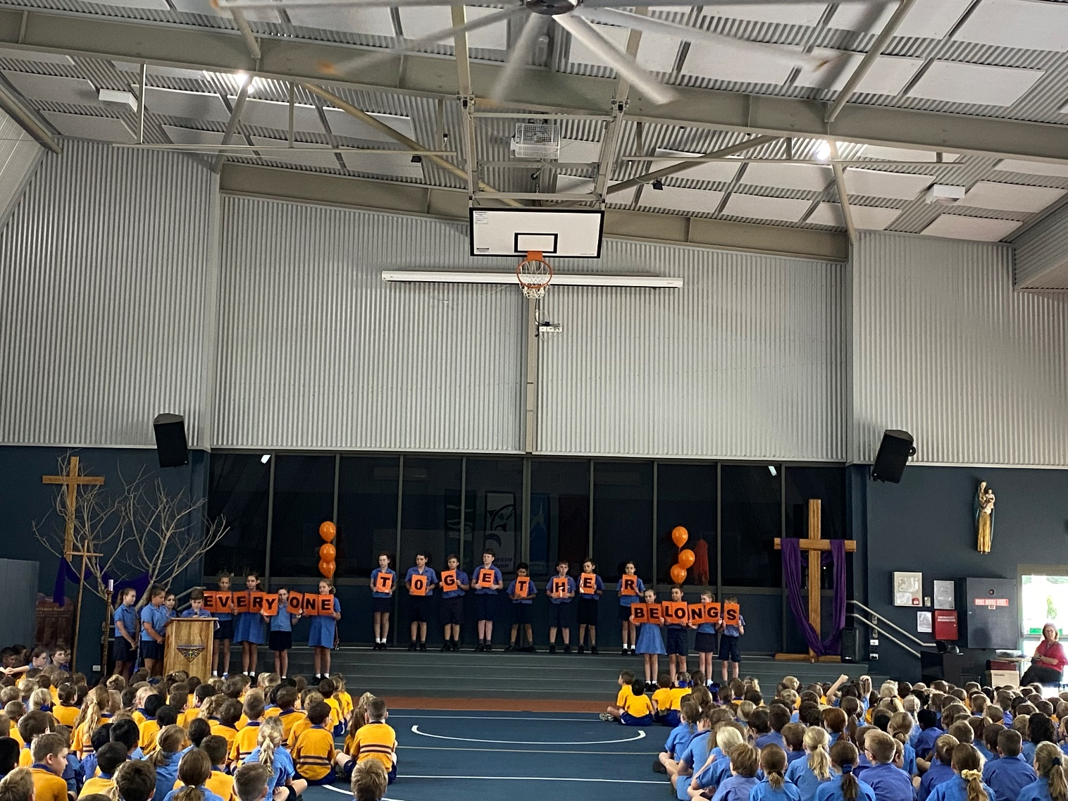

Last Friday 5C lead the school in prayer at Assembly. They described ‘**harmony**’, reminded us that we are all part of God’s family and encouraged us to welcome and treat others with kindness.

Throughout the week all classes have participated in activities that promote respect and acceptance. Some classes have shared and discussed Mem Fox’s “I’m Australian Too”, while others have explored what harmony looks like, sounds like and feels like at home and school. Investigating diversity has allowed students to appreciate the contribution that each one of us can bring to the community. A video clip of harmony in action at Emmanuel has been played in the library at lunchtime each day. The students have loved seeing themselves on the screen.

Many students and staff wore something orange (ribbons, socks, shoelaces) to school today and there were orange balloons on posts outside the office and classrooms. It has been a wonderful week of celebrations.

**Prayer for God’s Mercy: COVID-19**

**Heavenly Father, we thank you for the gift of good health and peace**

**that we have enjoyed for so many years. As we find ourselves in this**

**time of crisis today, we ask for your divine intervention and mercy**

**to be upon each of us.**

**Come and guide the minds of those working to discover a**

**treatment to the COVID-19 virus. Grant them wisdom, knowledge,**

**and clarity of mind, so that all peoples will be free from**

**the threat of this ailment.**

**We also pray for the healthcare workers that are standing in the**

**front line of this battle. Father, we thank you for their hearts of**

**service, putting the needs of society before their own, generously**

**responding to the cry of Your people. We ask that You will grant**

**them strength and protection. As they give of themselves in**

**selfless service, may You fill them with your Holy Spirit**

**as they work to be Your healing hands and feet!**

**Father, we also surrender to You all those who have been afflicted**

**with the virus. Grant them Your healing grace, merciful Father,**

**so that they may recover swiftly and continue to be witnesses**

**of Your love in their lives.**

**Mother Mary, we ask for your intercession in this great time of need.**

**Cover each of us with your blue mantle of protection, so that we may**

**be preserved in good health to continue to glorify your son, Jesus Christ.**

**We make this prayer through Christ, our Saviour and Redeemer.**

**Amen.**

**Prayer Source: Roman Catholic Archdiocese of Singapore:** <https://www.catholic.sg/prayer-for-gods-mercy-covid-19/>



**Our School Mass, which was scheduled to be celebrated next**

**Friday 27 March at St Joseph’s Church, has been cancelled.**



**WOW WEDNESDAY**

This Lent we have been answering God’s call to love others and to care for His beautiful world by supporting WOW Wednesdays. Together we are making a difference. Keep up the great effort everyone.

**Easter Raffle**

Tickets in our Easter Raffle are now on sale. They are great value at a cost of 50 cents each or three for $1.00. Our Year Six Leaders will be selling the tickets before school and at lunchtime each day. The raffle will be drawn in the last week of school. All money raised will be forwarded to the missions.

A big thank you to the Emmanuel Staff for donating all the goodies for this multi-draw raffle.

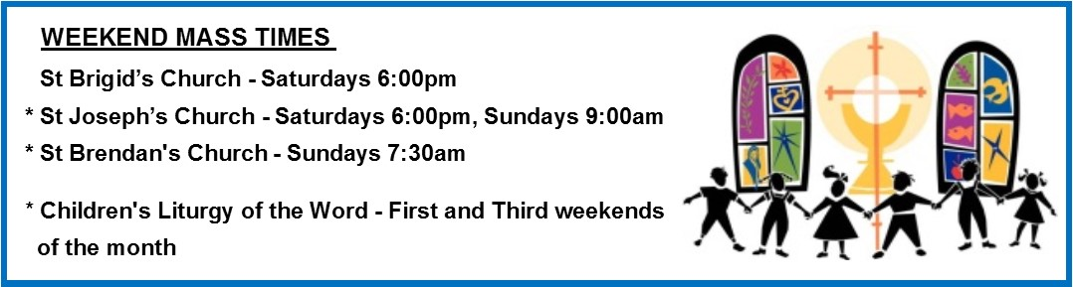

**LINK to Parish Website** **and Parish Bulletin:** <http://rok.catholic.net.au/parish/mackay-st-josephs/>

Respect is an attitude of honouring ourselves and others as people of value. We care for each person’s dignity. We show respect in the courtesy of our words and in our tone of voice. When we treat others as we would like to be treated, we raise the level of trust and peace in our relationships. Respect is having reverence for the Earth and all living things. When we live respectfully, we are a source of grace in the world.

***“Respect means you care enough to think about others’ feelings, before you act.”***  (Unknown)

Noeleen Kliese

*Assistant Principal Religious Education*



Tomorrow (Friday 18 March) is National Day of Action against Bullying and Violence. With increasing use of technology in our everyday lives and the lives of our children it is important to teach them how to be responsible users of technology. With this in mind and such an important day ahead I would like to share with you some sections from the Catholic Education Office “Cyber Safety and Cyber Bullying: Guide for Parents”.

Let’s begin by looking at CEO’s definitions of Cyber Safety and Cyber Bullying.

*“Cybersafety is a broad term referring to appropriate and responsible behaviour online – it covers online privacy and information protection, good manners and behaviour online, and knowing how to get help to deal with online issues.”*

*“Cyberbullying is when technology, such as email, mobile phones, chat rooms and social networking sites, are used to verbally or socially bully another person. Bullying is an ongoing abuse of power to threaten or harm another person.”*

Following are some common examples of cybersafety issues, including cyberbullying:

* Sending or posting abusive, threatening, humiliating or harassing messages via text, social networking sites or email.
* Forwarding others’ personal emails, messages, pictures or videos without their permission.
* Uploading embarrassing or degrading images or videos involving other children (including fight videos)
* Taking and sending sexually explicit images of other children using mobile phone or web applications
* Using social networking sites or blogs to post inappropriate photographs or messages about other children and school staff.
* Excluding children online through emails, chat and social networking sites.
* Imitating others or assuming a child’s identity, then sending and posting material which damages their social status or relationships with others.
* Making prank calls to another child’s mobile phone.

As guardians of student users, it is also important for us to educate ourselves on how to best work and supervise our children so as they grow to become responsible users of technology. This year all students in Years 3 – 6 are engaging in Modules from the Alannah and Madeleine foundation to earn their esmart Digital Licence, educating and encouraging them to be safe users of technology. Click on the following link if you would like to have a closer look at this cyber safety program <https://www.digitallicence.com.au/>

Janine Refalo

*Assistant Principal Curriculum*



**555**

**APA News**

**NATIONAL DAY OF ACTION AGAINST BULLYING AND VIOLENCE**

Tomorrow, Friday 20 March, is the National Day of Action Against Bullying and Violence.  As we will not be gathering at our School Assembly tomorrow, we will recognise this important event in classroom activities next week.  It is timely to look at the procedures for handling bullying at Emmanuel.  These include:

1. listening openly to all sides of the story and clarifying the facts and feelings involved
2. speaking to all participants separately to clarify what they want from the other person/s
3. bringing the two parties together to confirm facts and feelings in the company of a mutually agreed group of peers (if appropriate to the situation) who act as supporters and observers
4. Using the technique: When you do……….

I feel………………….

I would prefer you to …………..

1. Deciding mutually acceptable behaviours for the future
2. Making appropriate apologies
3. Encouraging confidentiality
4. Explaining that on the first occasion it is an informal procedure; repeat offences would include parents and formal warnings.

# Ways to Report Bullying

Students often feel that to deal with the problem of bullying can only make it worse. Students are encouraged to realize that bullying can only be dealt with if a significant adult knows about it. The significant adult could be a parent or a teacher.  Bullying can be reported by:-

1. telling a parent, teacher or member of the Administration Team
2. having a friend speak to a significant adult on your behalf
3. Using the “Bullying Box” located in the Library

Signs for parents to look for that a child is being bullied.

* bed wetting
* crying or emotional upset that seems unusual
* not wanting to go to school
* not wanting to be left with certain people
* any changes in sleeping or eating habits
* loss of confidence

Signs for parents to detect if your child is at risk of becoming a bully.

* has difficulties seeing another person’s point of view
* likes to win at all costs
* bullies sisters or brothers
* is bullied by family members
* if fighting, arguing and teasing are acceptable at home
* has difficulty keeping or making friends
* has low self esteem
* “looks for trouble"



**DEALING WITH CORONAVIRUS AT EMMANUEL**

Information went home to parents via email on Tuesday about our response to COVID-19. A number of events have been cancelled and others have been postponed until later in the year. As a school we have implemented additional measures to support the health and safety of everyone in our community.

**Should your child feel unwell please keep them home from school. Students who are unwell during the day will be sent home.**

Protective measures include:

* Increased focus on good hygiene practices
* Exclusion of students and staff with flu-like symptoms
* Cancellation of whole school gatherings
* Increased cleaner’s hours
* Cancellation of school sport

**EFFECTIVE HAND HYGIENE IS VITAL**

As the coronavirus (COVID-19) continues to evolve, it is important to remember that effective hand and sneeze/cough hygiene is the best defence against viruses and can help prevent the spread of illness.

Lead by example and encourage your children to:

* wash their hands regularly with soap and water, before and after eating, and after going to the toilet
* use alcohol-based hand sanitiser if soap is not available
* cover coughs and sneezes with a tissue or the inside of their elbow
* dispose of tissues in the bin immediately
* if they’re unwell, stay at home and avoid contact with others such as touching, kissing or hugging.

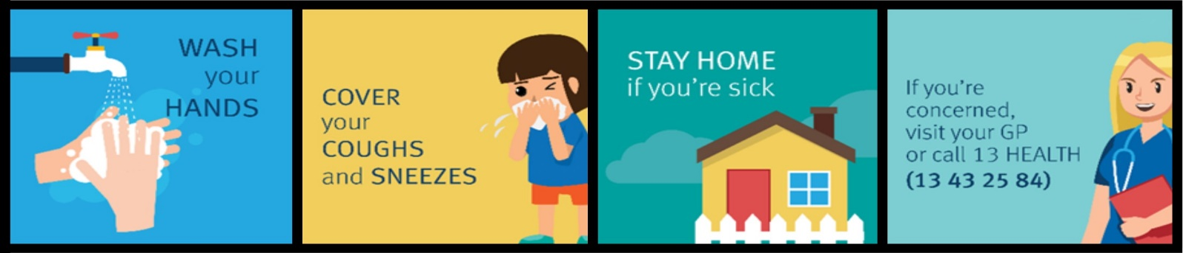Check out effective handwashing @ [youtube.com/watch?v=NpmB80pWUsk&feature=youtu.be](https://www.youtube.com/watch?v=NpmB80pWUsk&feature=youtu.be)

**PARENT COMMUNICATION**

Parents are asked to please ensure that your current personal details recorded on our school communication systems are up-to-date.  It is imperative that these details are updated regularly in order for us to communicate any important information to the school community at all times.

We are in constant contact with members of the Diocesan Catholic Education Office so as to ensure the most up-to-date information is shared with our school community, particularly in light of the current issues surrounding the recent outbreak of Coronavirus.  Information will be promptly communicated to families as it comes to hand.

Please contact the school office, or update your details on Parent Lounge should you need to do so. Should you not be receiving regular information from the school, such as text messages, emails, etc, you are asked to notify reception so that this may be rectified.

**PREP ENROLMENTS 2021**

Prep enrolment details for 2021 are NOW required from our existing families. If you have a child due to commence Prep next year born between July 1, 2015 and June 30, 2016 please complete an online enrolment form available from the school website - https://www.ecps.qld.edu.au/application-for-enrolment.html by Friday 3 April. It is essential that we have our current families accounted for so as to determine how many positions may be offered to new families seeking enrolment. If you have any queries or concerns, please contact the office. Interviews will commence in Term Two.

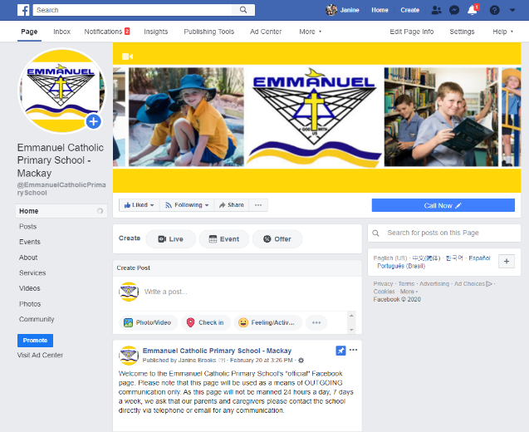**SCHOOL FACEBOOK PAGE**

As previously advertised, Emmanuel’s official Facebook page is now Emmanuel Catholic Primary School – Mackay. We will no longer be using the Emmanuel P&F Facebook page.

There is another unofficial Emmanuel page which has no affiliation with the school and is not manned by Emmanuel staff.

Please look for the logo (pictured) so that you are “liking” the correct page. The link is attached for your convenience.

<https://www.facebook.com/EmmanuelCatholicPrimarySchool/>

Amanda McDonald

*Assistant Principal Administration*



**From Our Counsellor**

It seems that as we hear about bullying in the broader community, parents and students agree that it is unacceptable. Bullying of any kind has the potential to cause great damage and distress to a person’s psychological and mental wellbeing. As parents and carers, there are steps that can be taken to protect our children. Following are some helpful websites which contain tips and strategies that can promote social and emotional resilience, and support those facing challenges associated with bullying. Further, it’s important for our children to build ‘digital intelligence’, so that they can safely navigate the digital world. This can be done by educating children on how to avoid harmful online experiences by exploring websites, apps, gaming and social media together with carers, and setting some e-safety rules.

This week, the national day of action against bullying, gives students the opportunity to stand up unitedly against all forms of bullying. Bullying can occur both covertly (indirectly) and overtly (directly). Indirect, covert bullying can inflict psychological harm to someone, through intentional damage to a person’s social reputation, peer relationships, and self-esteem. Covert bullying can be difficult to identify, as it can include threatening or weird looks, spreading rumours, repeated hand gestures, excluding or turning your back on a person, criticising, snubbing (ignoring), restricting where a person can sit or who they can talk to. It can involve power and control in relationships, with the intent to control another person.

To support the Bully No Way day, students can become up-standers within the community, recognising the opportunity in becoming an active bystander rather than a passive bystander in social interactions. A way to be an up-stander in your own community, is to be considerate in supporting all population groups.

Please take an opportunity to check out the website and discuss the important issues with your children, as your children are more likely to come to you with concerns if you have opened the communication door previously. The upcoming holiday time might be a good time to discuss these issues with your children.

<https://bullyingnoway.gov.au/>

<https://www.esafety.gov.au/>

Yours in counselling, Kristy Flor.



**Sports News**

# INTERHOUSE SWIMMING CARNIVAL POSTPONED

# BLUE WATER LAGOON EXCURSION POSTPONED

# ALL MACKAY DISTRICT SCHOOLS TRIALS SPORTS AND EVENTS CANCELLED

Luke Dodson

*HPE Teacher*



**Music News**

**CHORAL FESTIVAL CANCELLED**

**SCHOOL CHOIR**

Rehearsals each Wednesday morning 8am in the Chapel – Years 4, 5 and 6 students – new members are very welcome to attend.

**MUSICORP**

Musicorp lessons will take place every THURSDAY.  Please ensure your child brings their instrument / music in preparation for their lesson.

**GUITAR LESSONS**

Mr Jim will be conducting Guitar Lessons every WEDNESDAY at Emmanuel. Students from Years 1-6 are able to participate.  Please contact the office if you require a form.

Linda Miller

*Music Teacher*

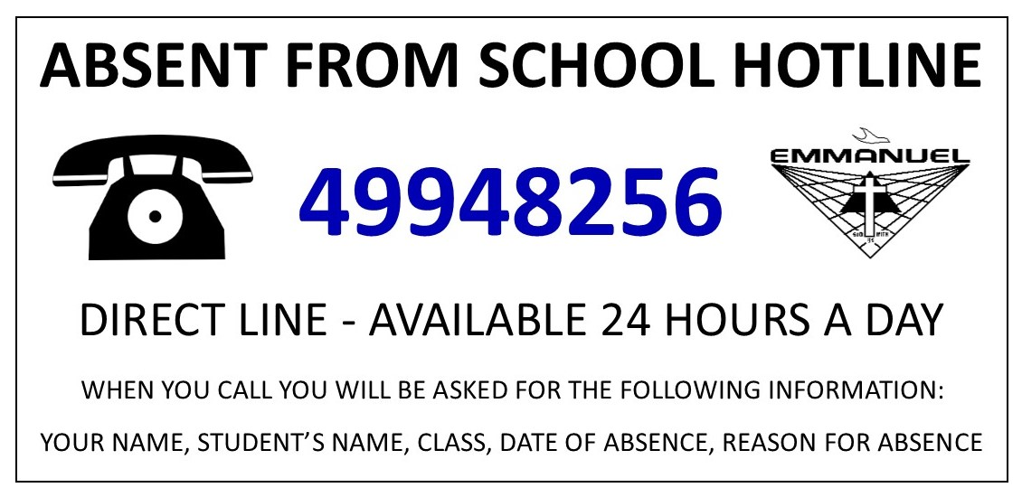

**Respect**

**Kindness**

**Compassion**

|  |  |  |
| --- | --- | --- |
| ***Prep*** | Emmy Zarb  Jhysen Woods | Isabella Shand  Jack Hammond |
| ***Year 1*** | Alice Smith | Max Camargo |
| ***Year 2*** | Fynn Ayles  Lilly Bartolo Koby Buckeridge | Te Wera Goodwin-Burke Liliana Langford  Charlotte Phillips |
| ***Year 3*** | Brody Walmsley  Vesper Horan  Harley Pace | Abbie Pritchard  Annabelle Brandon |
| ***Year 4*** | Jasmyn Craig  Harrison Webber | Ruby Deguara  Cooper Saunders  Harry van der Linden |
| ***Year 5*** | Elysse Brown  Brendan Scriha  Jhett Martin | Hudson Synnott  Sienna McEvoy  Matilda Lewis |
| ***Year 6*** | Sophia Lo Presti  Tess Armstrong  Alvin Anuji | Blayde Parkinson  Lila McGrath  Masey Kelly |

**VIRTUE VOUCHERS**

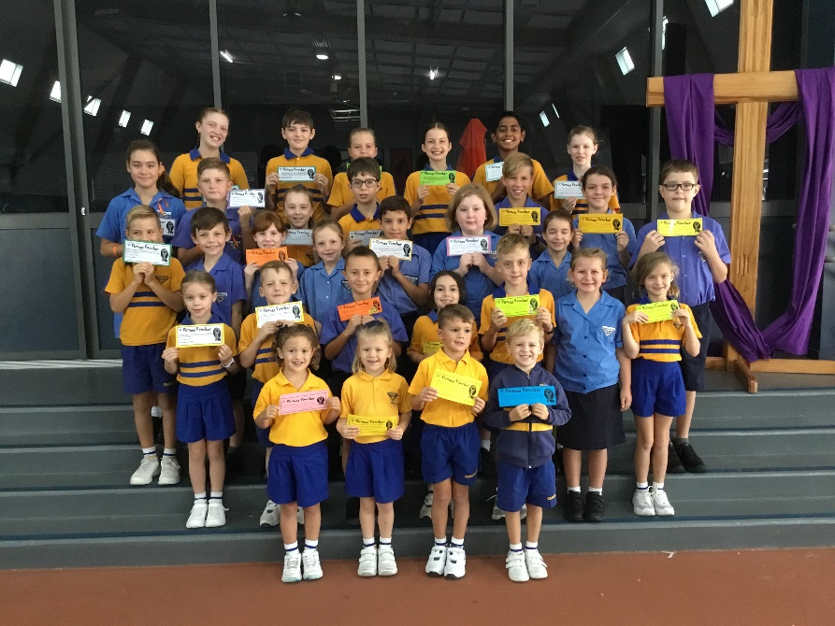

**Friendliness**

**Co-operation**

**Helpfulness**



Tuckshop News



|  |  |
| --- | --- |
| Tuckshop Roster – Week Nine | |
| Monday 23 March | Jean Grima |
| Tuesday 24 March | HELP WANTED |
| Wednesday 25 March | Renae Borg |
| Thursday 26 March | Nicci Lewis |
| Friday 27 March | Dianna Camilleri  Lauren Gossweiler |

A BIG THANK YOU to all of our wonderful tuckshop volunteers. Your help is very much appreciated.

**CASSEROLE CLUB**

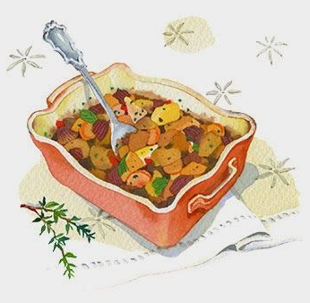

As you may be aware, our school community has a Casserole Club whereby parents volunteer to cook meals for a family in need. This is one way that our school community can practically support those in our school who are facing hardship.

If any parents, including those who have previously volunteered, are willing to be part of the Casserole Club please contact the school office with your name and phone number. Your name will be placed on a register and in times of need, you will be contacted and asked to cook a meal and bring it to the school office for delivery.

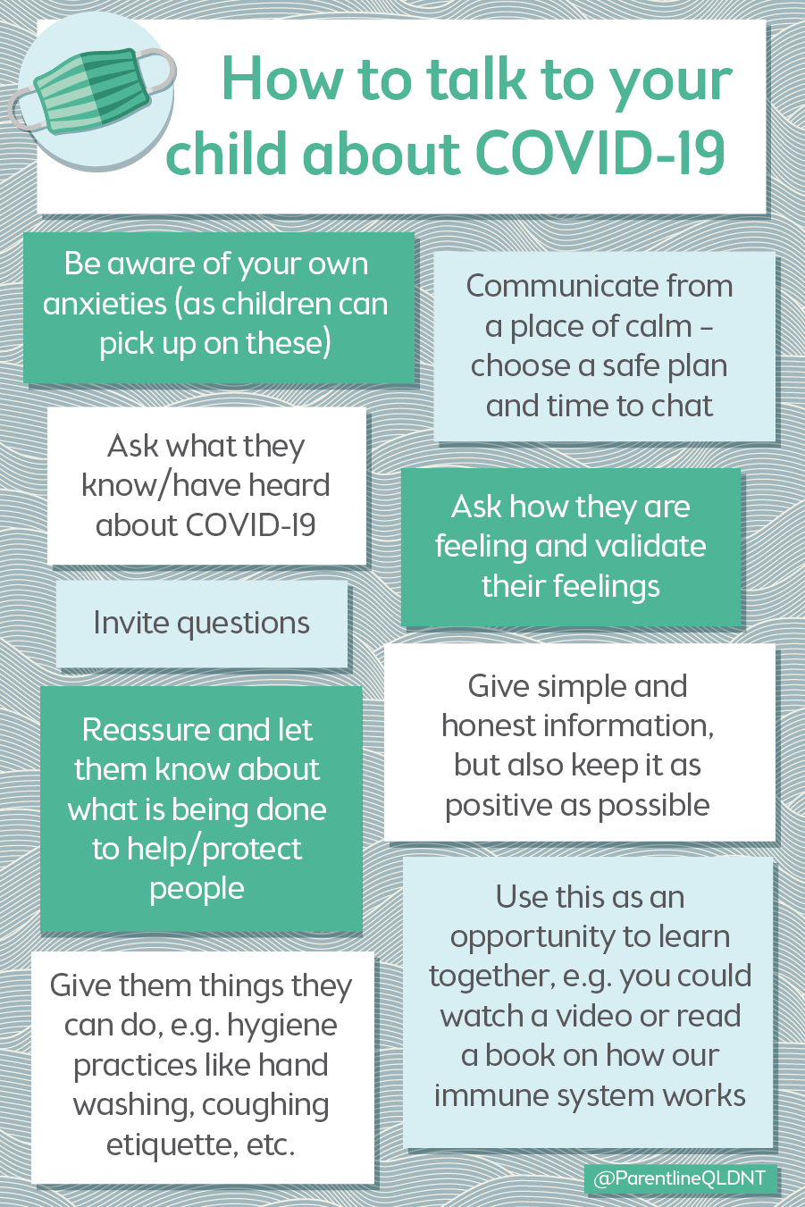

Dis

