18 June 2020

Term Two
Dates to Remember

Tuesday 23 June and Wednesday
24 June
School Photos

Friday 26 June
Last Day of Term 2

Our School
Mission Statement

Dear Parents,
Every generation, pre-teens and teenagers have always found a way to create problems for their parents and teachers. In the 50’s it was rock n roll, 60’s hippie culture, 70’s fashion blow outs, etc. This age group of course has and will always involve rebellious behaviour at some stage…it’s all part of growing up. I suppose each generation has had to deal with common issues such as drugs, alcohol consumption, body image, self-esteem, peer pressure, etc. However, with this generation it is the misuse of social media that has the potential to cause problems with all involved.

I have attended conferences and read articles on the pitfalls of the misuse of social media and the associated complications it has for this age group to function as normal members of society. Strong parenting is a common message but I believe it is too broad a statement, for as every teenager is different so is every parent. We all have our own idea of what strong parenting is. The best definition of what a strong parent is one that does not give in.

The following article provides wonderful advice and I urge every parent, no matter what ages your children are, to take the time to read it. Don’t fall for the trap in believing it won’t happen with my child and don’t wait till a problem arises. Be proactive and start now to instil correct and proper behaviour whilst using social media.

“It’s important to start conversations with children about using social media at a young age to prepare them to be savvy users when we’re not around.

“If a job’s worth doing, it’s worth doing well.”

This mantra always pops into mind whenever I’m about to cut some corners or do a rushed job in any endeavour. As a result, I double-check every article I write for mistakes. I over prepare every talk I give. And I continually edit and re-edit my books. This message keeps me at the top of my game. I can thank, or blame, my mother for inserting this mantra in my mind as she repeated it whenever I did a rushed job as a youngster making my bed, doing homework or cleaning up my bathroom mess.

Parents of every generation have always found ways to frame messages of safety and success for their children to remember. Parents of past generations who only had to contend with the offline or real world intuitively knew that they needed to teach child important lessons about safety and manners rather than assume they’ll be understood.

The same maxim holds true for the world of social media that children now inhabit from an increasingly young age. Even though our children are growing up with technology as a part of their everyday lives, they will still make plenty of mistakes while using it. This means we need to have direct conversations with our kids about the comments and posts that are okay to make using social media of all forms.

As parents, we teach our kids to talk politely and clearly so that they know how to speak to others when we’re not around. In effect, we give our kids social scripts to fall back on when they talk to friends, teachers and relatives. There’s no guarantee they’ll look an adult in the eye when they speak to them, but our discussions, reminders and lessons about manners will hopefully hold up when we’re not around. The same applies to social media. Our conversations and lessons will prepare them to be savvy users when we’re not around. Here are some ideas to get you started:

1. “Is this worth posting?” The relatively impersonal nature of social media means that we can post information and pictures with relative immunity. Also, its immediacy means that we can do so without much thought. This means that kids need to be very critical about what they see online. ‘Is this accurate?’ and ‘Is this worth posting?’ are two valid questions children can ask when they read posts placed by others.

2. “Have you taken a big breath?” A child who blurts out everything that comes into his mind without thinking is sure to put plenty of people offside. ‘Think before you speak’ is the type of message that every child should have in mind. The same applies to social media. Just because they think something doesn’t mean they post it. ‘Take a big breath’ may just about be the most important message to give your kids about social media.

3. “Do you want the principal to see this?!” An invitation to a teenage birthday party posted on social media is one way to get more attendees than you bargained for! The viral nature of social media means that kids should only post messages and photos that they want to be spread and read by a large audience.

4. “How does this post make you feel?” We need to teach kids that not every post needs to be commented upon and not every thought needs to be shared, particularly when they are angry. Teaching them to walk away and then to step back in when they’ve calmed down is perhaps the most important communication lesson of all. It is very relevant to social media as emotions are often the last thing on many people’s minds when they haphazardly post a message.

5. “How will you fix this?” Social media just like any social space requires kids to behave ethically and with kindness. When kids overstep the mark and post hurtful things then it’s fair that they fix their mistakes, and apologise. It’s reasonable that we teach our children to act with tolerance and with empathy online, and if mean things are posted then they should be expected to try to repair relationships through social media, just as they should offline.
[Michael Grose]

Wishing you every blessing for the coming week.

Geraldine Rostirolla
(Principal)

Religious Education

I WANTED TO CHANGE THE WORLD – A REFLECTION

When I was a young man, I wanted to change the world.

I found it was difficult to change the world, so I tried to change my nation.

When I found I couldn't change the nation, I began to focus on my town.

I couldn't change the town and as an older man, I tried to change my family.

Now, as an old man, I realize the only thing I can change is myself. I realize that if long ago I had changed myself, I could have made an impact on my family. My family and I could have made an impact on our town. Their impact could have changed the nation and I could indeed have changed the world.

(Author Unknown)

THIS SUNDAY’S READINGS:

Jeremiah 20:10-13
He has delivered the soul of the needy from the hands
of those who are evil.

Romans 5:12-15
As sin entered the world through one man, so through
one man are we saved.

Matthew 10:26-33
Those who acknowledge Christ will be known to the Father.

Living the Gospel – From the House-tops

One of the messages of Jesus to his disciples and, through him, of Matthew to the original community, is to have courage and to have pride in their belief. No matter what threat or persecution they are to endure, the command is to proclaim the message of Jesus from the house-tops. They are to be proud of what they believe and be prepared to share it with others. In a world today that is not always open to the message of Jesus, we too are called to be proud of what we believe and not whisper it in the darkness. (Greg Sunter)

For weekly Gospel readings, reflections and meditations go to http://www.prayasyoucan.com.au/

For Parish News and updates check out the Catholic Parishes of North Mackay and Farleigh Facebook page.

Share in Daily Mass from St Joseph’s Cathedral @ https://www.youtube.com/channel/UCQeYD6B2cSvFb4zqStn_Brg

MJR AT HOME AND SCHOOL (and some of my favourite quotes from St Teresa of Calcutta)

Not all of us can do great things. But we can do small things with great love.

MJR emphasises the spirituality of the everyday, so lots of the things we do each day and week are Making Jesus Real in the world today. Every time we greet, speak and treat others with respect and kindness; use good manners; welcome, encourage and include others; say ‘Sorry’ and ‘Thank you”; take responsibility for our words and actions; and treat those around us how we would like to be treated, we share the love of Jesus and live as He taught us to.

Spread the love of God through your life, but only use words when necessary.

I can do things you cannot, you can do things I cannot; together we can do great things for God.

I am a little pencil in the hand of a writing God who is sending a love letter to the world.

I alone cannot change the world, but I can cast a stone across the waters to create many ripples.

What will you do this week to Make Jesus Real in your home, workplace and community?

AUSTRALIA’S BIGGEST CHILD SAFETY LESSON (ABCSL)

Each year the Daniel Morcombe Foundation produce Australia’s Biggest Child Safety Lesson. This year they will provide two lessons. The lesson for students aged 8-12 will focus on online safety strategies, while the lesson for students aged 4-7 will highlight safe and unsafe secrets.

Although the first of these lessons will be live screened next week, we have decided that students in all year levels will participate in these lessons during National Child Protection Week in September. This will also coincide with the implementation of the Daniel Morcombe Child Safety Curriculum at Emmanuel in Term Three.
For more information about ABCSL and to view lessons from previous years go to:
https://danielmorcombe.com.au/australias-biggest-child-safety-lesson-2/

For resources and information about child safety go to:
https://danielmorcombe.com.au/fact-sheets/

To find out about the Daniel Morcombe Foundation and the key messages of the
Daniel Morcombe Child Safety Curriculum go to: https://danielmorcombe.com.au/

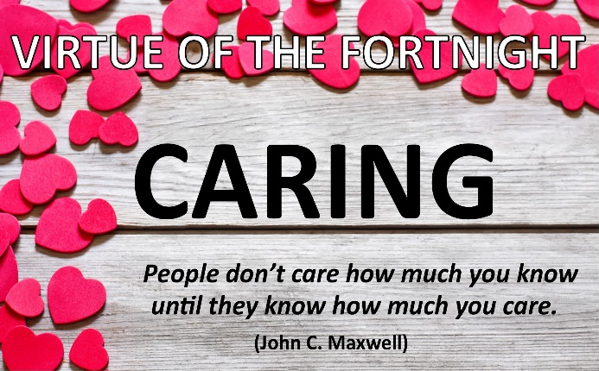
Caring is giving love and attention to people and things. When you care about others, you help and support them. You treat them gently and respectfully. When you take care of yourself, you treat your body with respect. You keep yourself clean and healthy. When you do a careful job, you give it your very best effort. Caring makes the world a kinder, safer place.

“Without a sense of caring, there can be no sense of community.” (Anthony J, D’Angelo)

Noeleen Kliese
Assistant Principal Religious Education

Curriculum Corner

REPORT CARDS
Report cards will be emailed to parents and will be accessible via Parent Lounge at the end of Week One, Term Three.
PARENT TEACHER INTERVIEWS
Saturday 18 July - Sunday 2 August

Parents were emailed instructions last week on how to book
Parent Teacher interviews through Parent Lounge.

Bookings open on Tuesday 16 June and can be made up
until 10:00am on Friday 26 June (last day of Term 2).

Janine Refalo
Assistant Principal Curriculum

APA News

SCHOOL PHOTOGRAPHS
School Photographs will take place on TUESDAY 23 JUNE AND WEDNESDAY 24 JUNE. Advanced Life Photographers have adjusted photography practices to accommodate current Covid19 restrictions. The company will take professional photos on an individual basis but NO TRADITIONAL GROUP PHOTOGRAPHS WILL BE TAKEN THIS YEAR. Instead, the company will provide a printed composite package that will feature your child’s class, plus your child’s portrait pack of choice.

As in previous years the payment method is ONLINE ONLY. The online order instructions are published below. Orders can be placed by following the instructions provided. Please note that to ensure a smoothly run photo day, online orders for Sibling/Family photos will be cut off at 12:00am on the night before our photo day - Monday 22 June.
Photos for Prep to Year 3 and some sibling photos will be taken on TUESDAY 23 JUNE, while students in Years 4 to 6, School Captains and House Captains, and remaining sibling photos will be photographed on WEDNESDAY 24 JUNE.

Students from Years 1 to 6 are to wear their blue day uniform, with girls wearing their school dress. Parents are asked to ensure that hair is neat and tidy, and hair longer than collar length is to be tied back. If hair bands, ribbons or scrunchies are to be worn, they are to be gold or blue of the school colours. No decorative hair accessories are to be worn.

Amanda McDonald
Assistant Principal Administration

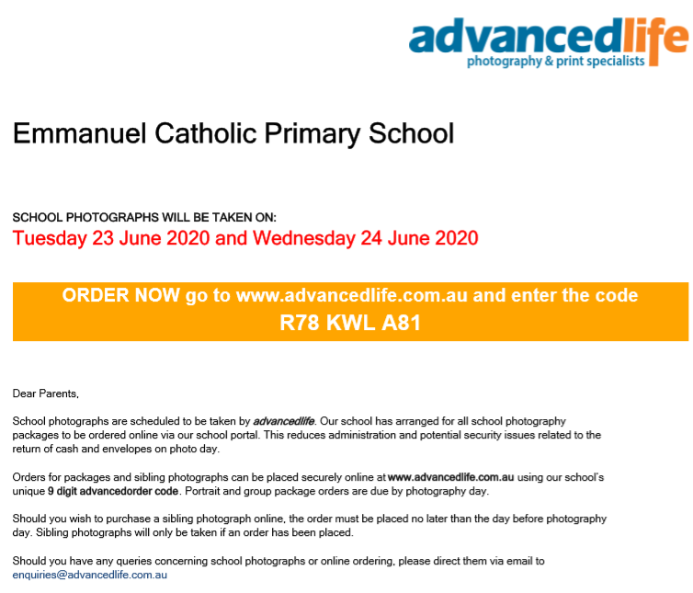
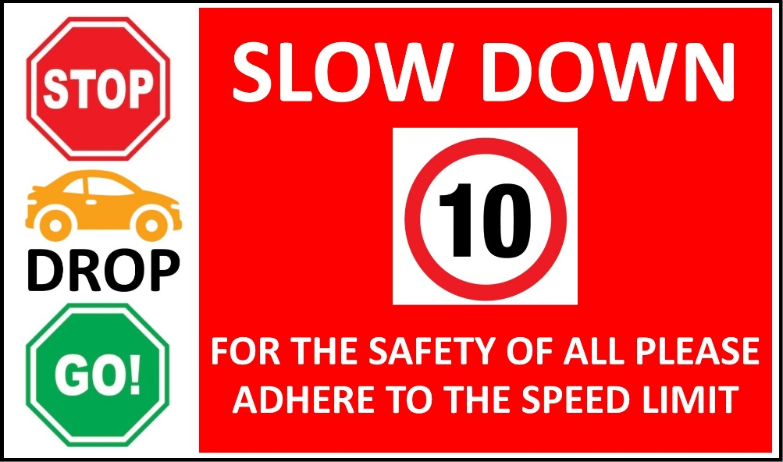

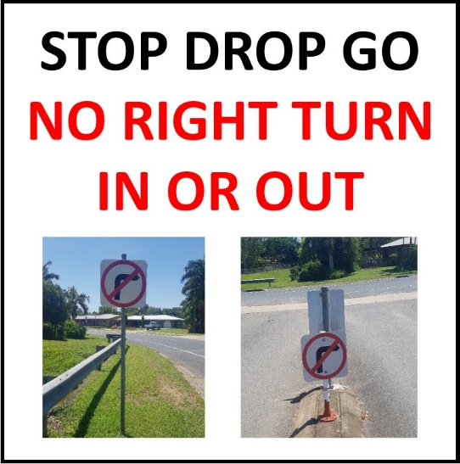

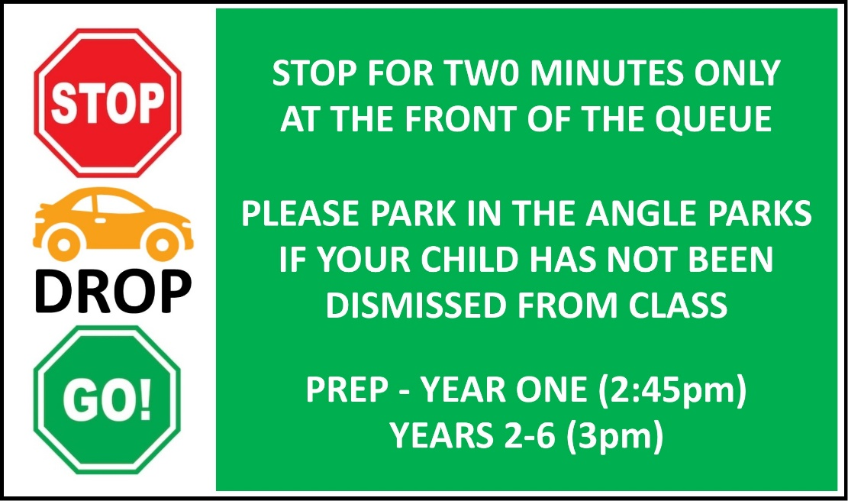

Sports News

As we come to the end of what can only be described as the craziest term in living memory, it has been decided that students need a fun game and sports day to see them into the holidays. On Friday 26 June (last day of term), all classes throughout the school will take part in either small group games or a walking soccer competition.

Prep to Grade 2 students will enjoy a morning session of fun games run by our Grade 6 students. Games will include Hungry Monkeys, Bugs and Spiders, Broncos v Cowboys and Jurassic World to name just a few.

After morning tea, our remaining students will fight it out in Emmanuel’s first-ever Walking Soccer Cup. All classes in Years 3 and 4 will compete for the highly prized ‘Twinkle Toes Trophy’ with classes in Years 5 and 6 vying for the prestigious ‘Smelly Boot Bowl’. Walking soccer is a great variation on the original game as it allows all students to compete at a similar level regardless of speed or ability. This will be a light-hearted competition with good sportsmanship and participation the overall goal. I’ve smelt the Smelly Boot Bowl and it is not something to fight over!

The day aims to provide all students with an opportunity to take part in fun physical activities with their classmates. All students are asked to wear their sports uniform, bring a water bottle to take with them and ensure they have their school hats.

I’m so excited to see students back on the sporting fields, enjoying healthy fun competition and being physically active.

Yours in sport,

Luke Dodson

CLASS | STUDENTS AND AWARDS
6K | Tui-Lee M - For the diligent and courteous way you have approached Term 2. You are completing all set work neatly and your input into our classroom discussions has been great to see. I am very proud of you Tui-Lee!
6K | Cameron S - For the positive and studious way you have approached Term 2. You are continuously working hard to achieve your goals and are doing a great job of ‘Governor General’ in our 6K parliament. You are a valued member of our classroom Cameron. Keep up the great job!
6S | Tess A – For consistently giving your best effort. You approach all tasks with drive and determination. You’re a role model to your peers.
6W | Amelia W – For the dedication you have been showing towards your learning. Mrs Whitaker is very proud of you. Keep up the great work Amelia!
6W | Sienna K – For displaying a positive attitude towards your learning. Mrs Whitaker is proud of the effort you are applying. Keep up the great attitude!
5C | Phoebe W – For always being considerate of others. You offer to help out wherever you can and you always rise to a classroom challenge. Well done, Phoebe!
5C | Marli W – For working so hard this week, particularly in English. You have been positive and putting in a great effort which has helped you make great improvements. Well done!
5F | Ella C – For your positive attitude in all that you do. This not only makes you a great friend but also a great student because nothing is too much trouble. Keep up the happy hard-working approach Ella!!
5F | Sullivan G – For your positive attitude in all that you do. This not only makes you a great friend but also a great student because nothing is too much trouble. Keep up the happy hard-working approach Sullivan!
5K | Ruby B – For your sunny smile, cheerful daily greeting and the positive energy you bring to our classroom every day. Thank you Ruby!
5K | Harry B – For your enthusiastic approach to all learning and the care and thought you put into every task. You are a superstar!!
4E | Mia N – For the positive attitude you are demonstrating towards your learning. Mia your “have a go” attitude is wonderful to see. Well done Mia!
4E | Sam R – For the efforts you have been displaying towards your learning; participating in class discussions, group work and Daily 5 activities. Well done Sam!
4E | Isaac S – For your efforts towards your learning especially during Daily 5 activities. Well done Isaac!
4S | Kaiden N - For demonstrating a fantastic effort to incorporating description into his writing. Well done Kaiden! I can see a growing confidence and enjoyment of writing this term.
4S | Sophia W - For showing a focussed and hard-working approach to your learning in all subject areas. Well done Sophia!
4W | Alex J – You are an amazing story writer. Your love of reading helps you to be so creative.
4W | Ella F – For always applying yourself to everything you undertake. You are willing to go the extra mile to help yourself learn. What a girl!!
4W | Haylee D – For always putting in 100% effort towards all tasks. You are a champion!
3P | Mila Z - For always looking for ways to help out your classmates. You are a role model for all.
3P | Jack N - For the hard work and dedication you put into all of your work. Keep up the great effort Jack!
3M | Mia S – For your creativity and imagination. 3M enjoys listening to your captivating narrative and persuasive opinions. Well done Mia!
3M | George C – For the wonderful work you are consistently producing in regards to regrouping algorithms. Keep up the great work. You are a Maths star!
3W/D | Daniel Z - For enthusiasm and expertise with Maths. Keep up the excellent effort Daniel!
3W/D | Monique S - For the effort and pride towards your work. It is exceptional. You are an excellent role model in 3W/D Monique. Well done!
2B | Kayden R - Listening intently and putting in your best effort in all activities. Mrs Brandon is very proud of your hard work in class!
2B | Miguel S - Listening intently and putting in your best effort in all activities. Mrs Brandon is very proud of your hard work in class!
2M | Caleb B – For a pleasing start to the term back at school. You have been working hard to treat others with patience and have made excellent progress since the beginning of the year. Keep up the great effort, Caleb!
2M | Lola L – For her amazing efforts to improve your reading. Lola has been working very hard both at home and at school to build her reading strategies. Miss Menzies is so proud of you, Lola! Keep up the great work!
2R | Juliet T – Congratulations Juliet! You consistently demonstrate behaviour that sets the standard for our class. Keep up the wonderful effort!
2R | Hayley M – Congratulations Hayley! For always taking great care with your work and having a positive attitude towards all aspects of school life. Keep up the wonderful effort!
1C | Lainee S – For working hard and listening carefully at all times. You are always trying your best. Well done, Lainee!
1C | Nakulan N - For a big improvement in your ability to stay focused in class. Miss Cordingley is so proud of you, Nakulan!
1M | Sophia P – for approaching every day with enthusiasm, cheerfulness and a willingness to do your best.
1M | Korbyn R – For always trying your best and taking pride in the presentation of your work.
1T | Lincoln P – The improvements you have made in your daily writing. Miss Thomas can see the effort you are putting in each day and is so proud of you. Keep up the great work Lincoln!
1T | Parker B – For the way you approach every task with a positive attitude and apply yourself wholeheartedly. Miss Thomas is so proud of you!
PG | Emily V - For your wonderful contribution to class discussions and your enthusiasm for learning. Thank you for being such a wonderful role model for your peers. Keep up the great work.
PG | Ella E - For taking your time to put detail into your pictures and trying so hard with your letters and sounds. Keep up the great work Ella.
PJ | Jarvis M - For an enthusiastic attitude towards Maths activities. You always enjoy a challenge and persist until you have reached a solution. Well done, Jarvis!
PJ | Nate S - For a fabulous oral presentation about the weather. Prep J enjoyed listening to your talk and we could see you had practised lots at home. Keep it up, Nate!
PS | Nate H – For the effort you are putting into all subjects. You are becoming a writing wizard. Keep it up!

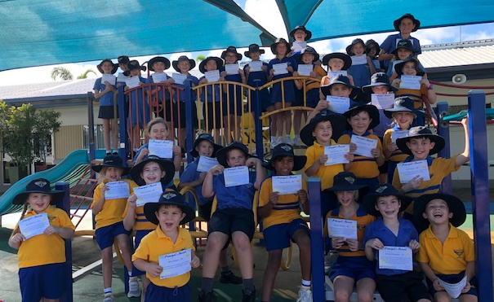

SCHOOL FEES
Term 2 School Fees now OVERDUE. We would like to thank those families who have paid.
A reminder if you have an eligible government health concession card, including all Carer, Disability and Mobility card holders, Job Seeker (JS) or Farm Household Allowance (FH), you are eligible for a 100% discount on the tuition levy component of the School Fees. Please contact Therese in the Finance Office with your details.
Families without a concession card, but who are experiencing financial stress are encouraged to contact the Principal, Geraldine Rostirolla as fee concessions are available. A simplified concession application form is available. To access this, please click here.

Tuckshop News

With our school holidays fast approaching, we need to reduce our stock, therefore some menu items will become unavailable over next week. We will adjust the online menu as this happens. Please have a second option noted on your child’s order in case a selected item isn’t available on the day. We apologize for any inconvenience.

Wishing you a safe and happy holiday.

Angie McGowan/Carly Nicholas
