21 March 2019
Term Planner

Dear Parents,

Every Fri
Assembly at 8:50am

March

Sun 24/Mon 25
Choral Festival

April

Wed 3:
Coin line

Fri 5:
Holy Week Liturgy – 9:30am

Last day of Term One

Tues 23:
Term 2 commences

Wed 24:
1/2 day carnival (Athletics)

Thur 25:
Anzac Day

Fri 26:
Full day carnival (Athletics)

The following is an excerpt from the book “Have You Filled a Bucket Today? by Author: Carol McCloud and Illustrated by David Messing. It is a guide to daily happiness for Kids and I would like to share it with you.

All day long, everyone in the whole world walks around carrying an invisible bucket. You can’t see it, but it’s there. You have a bucket. Each member of your family has a bucket. Everyone carries an invisible bucket.

Its purpose is to hold your good thoughts and good feelings about yourself. You feel very happy and good when our bucket is empty. Other people feel the same way, too.

It’s great to have a full bucket and this is how it works; You need other people to fill your bucket and other people need you to fill theirs.

So, how do you fill a bucket?

You fill a bucket when you show love to someone, when you say or do something kind, or even when you give someone a smile. That’s being a bucket filler. A bucket filler is a loving, caring person who says or does nice things that make others feel special. When you make someone feel special, you are filling a bucket.

But, you can also dip into a bucket and take out some good feelings. You dip into bucket when you say or do mean things, or even when you ignore someone. That’s being a bucket dipper. A bully is a bucket dipper. A bucket dipper says or does mean things that make others feel bad.

Many bucket dippers have an empty bucket. They think they can fill their own bucket by dipping into someone else’s…. but that will never work. You never fill your own bucket when you dip into someone else’s. but guess what…. when you fill someone’s bucket, you fill your own bucket too! You feel good when you help others feel good.

All day long, we are either filling up or dipping into each other’s buckets by what we say and what we do. You love your Mum and Dad. Why not tell them you love them? Your caring words will fill their buckets right up. Watch for smiles to light up their faces. You will feel like smiling too. A smile is a great bucket filler. Just remember that everyone carries an invisible bucket, and think of what you can say or do to fill it.

Here are some ideas for you. You could smile and say “Hi!” to the bus driver. He has a bucket too. You could invite the new kid at school to play with you. You could write a thank-you note to your teacher. There are many ways to fill a bucket. Bucket filling is fun.

When you’re a bucket filler, you make your home, your school and your neighbourhood a better place to be. Bucket filling makes everyone feel good.

At the end of each day, ask yourself, “Did I fill a bucket today?”

Wishing you God’s blessings throughout the Lenten Season,

Geraldine Rostirolla
(Principal)

Religious Education
THE ALPHABET PRAYER – A REFLECTION
A shepherd boy was watching his sheep one Sunday morning when he heard the bells of a nearby church ringing. As he watched the people making their way to Mass, he thought to himself, "I would like to communicate with God, but, what can I say to God?"

He had never learned to pray and did not know a single prayer. So, on bended knee, he began to recite the alphabet. He repeated this ‘prayer’ several times. A man passing by heard the boy's voice and saw him kneeling with his hands joined and his eyes closed.

He interrupted the boy. "What are you doing, little one?" he asked.

The boy replied, "I was praying sir."

The man seemed surprised and said, "But why are you reciting the alphabet?"

The boy explained, "I don't know any prayers, sir, but I want God to take care of me, and to help me care for my sheep……and so I thought, if I said the alphabet, He could put the letters together into words, and He would know all that I need, want and should say!"

The man smiled and said, "Bless your heart, God will!" and he went on to church knowing full well that he had heard the finest sermon he could possibly hear that day.

(Author Unknown)

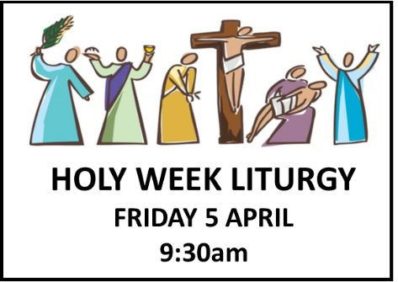

PRAYING THIS LENT
Prayer is a dialogue. It can be talking to God, listening to God, praising God, or thanking God. It can be silent, spoken, sung, confessed, or written. Prayer is being with God, being aware of God, sitting in the presence of God. It develops our relationship with the God who calls us to relationship. Prayer is a gift from God.

Pope Francis tells us that praying does not have to be difficult, that you can pray anytime, anywhere and everywhere. Why not try his Five Finger Prayer? It is a simple and thoughtful way to pray each day. Using the fingers on your hand, start with the thumb and pray these intentions:
1. Thumb is the closest to you, so pray for those who are closest to you. They are the people you know the best and are easiest to remember.
2. Pointer (index) finger is next. Pray for those who teach you, instruct you and heal you. They need the support and wisdom to show direction to others.
3. Tallest finger follows. It reminds us to pray for our leaders, those in government and those who have authority. They need God's guidance.
4. Ring finger is our weakest finger. It should remind us to pray for the poor, the hungry, the sick and suffering. They need your prayers.
5. Little finger, the smallest of all reminds you to pray for yourself.

Check out the fabulous free app Laudate. It is an amazing prayer resource, with Daily Readings and Saints of the Day, Order of the Mass, Traditional Prayers, Meditation, Catechism, Psalms, Rosary, Stations of the Cross, Vatican Documents and much more.

This Sunday’s Readings
Exodus 3:1-8. 13-15
The Lord calls Moses from a burning bush.

1 Corinthians 10:1-6, 10-12
We must learn from the example of our ancestors.

Luke 13:1-9
The parable of the fig tree.

MARY SAID ‘YES’
On Monday 25 March we celebrate the Solemnity of the Annunciation of the Lord. On this day we remember that Mary opened her heart completely to the Divine Presence, that she agreed to be the mother of Jesus. She put her life entirely into the hands of God saying “Behold, I am the handmaid of the Lord.” Doing this changed her life, and ours, forever.

How can you say ‘YES’ to God today?

LENTEN CHALLENGE
This Lent we will once again be having a Coin Line Challenge to support those less fortunate than ourselves. Each class will line up their coin donations. There will be two prizes – one for the class with the longest coin line and the other for the class with the coin line with the greatest value. It will be fabulous to see how far our money can go.

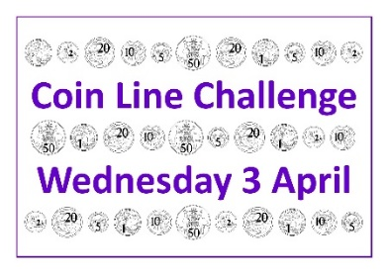
All families are encouraged to donate gold and silver coins and in doing so love and support others. The Coin Line Challenge will be held on Wednesday 3 April. Money can be sent to school ahead of the challenge.
PROJECT COMPASSION
Last week we shared the great news that we had collected enough money through our Project Compassion collection boxes to provide twelve schools in the Solomon Islands with a water tap. This week we are happy to report that we have now accumulated enough money to also support midwives in rural Bangladesh who provide antenatal care to expectant mothers.

Please encourage your child to do a job to earn a small contribution and allow them to appreciate the difference that they can make to the lives of people they don’t even know.

For more details about Project Compassion and how you can help this Lent, go to the CARITAS website @ http://www.caritas.org.au/projectcompassion

HARMONY DAY
Harmony Day celebrates Australia’s cultural diversity. It’s about inclusiveness, respect and a sense of belonging for everyone. Harmony Day is an opportunity to appreciate the multi-cultural nature of our society, from the oldest continuous cultures of our first Australians to the cultures of our newest arrivals from around the world, and to value the diverse contributions of all who call Australia home.

At Emmanuel we celebrated Harmony Day today. Many students and teachers wore something orange (ribbons, socks, shoelaces) and all classes participated in activities that promote respect and acceptance. There were orange balloons on posts outside the office and classrooms.
Year 5K/N will lead us in prayer at Assembly tomorrow. Their prayer will have a harmony focus and remind us that we are all part of God’s family and that we all belong.
Seasons for Growth
Learning to live with change and loss

Change and loss are issues that affect all of us at some stage in our lives. At Emmanuel we recognise that when changes occur in families through death, separation, divorce or related circumstances, young people may benefit from learning how to manage these changes effectively. We are therefore offering a very successful education program called Seasons for Growth.

This program is based on research that highlights the importance of social support and the need to practise new skills to confidently cope with change and loss. Activities and discussions teach that grief is like the seasons – cyclical in nature, and a natural part of life. The program focuses on issues such as self-esteem, managing feelings, problem solving, decision-making, effective communication and support networks. It does not provide counselling or therapy.
Seasons for Growth runs for eight weeks and all sessions are conducted in school hours, with groups of 4-7 children accompanied by a trained Seasons Companion.
If you think your child would benefit from participating in the Seasons for Growth Program or you require additional information, please contact your classroom teacher or Mrs Kliese in the office.

Easter Raffle
Tickets in our Easter Raffle are now on sale. They are great value at a cost of 50 cents each or three for $1.00. Our Year Six Leaders will be selling the tickets before school and at lunchtime each day. The raffle will be drawn in the last week of school. All money raised will be forwarded to the missions. A big thank you to the Emmanuel Staff for donating all the goodies for this multi-draw raffle.

VIRTUE OF THE FORTNIGHT – COMPASSION
Compassion is understanding and caring when someone is hurt or troubled, even if you don’t know them. It is wanting to help, even if all you can do is listen and offer kind words. You forgive mistakes. You are a friend when someone needs a friend. Without compassion the world is a hard and lonely place. Compassion helps us to be understanding of others and ourselves.

“If you want others to be happy, practise compassion.
If you want to be happy, practise compassion.” (Dalai Lama)

Noeleen Kliese
Assistant Principal Religious Education
Curriculum Corner
NAPLAN Online Practice Test
During the last week of Term, students in Year 3 and Year 5 will be participating in the NAPLAN Online Practice Test. The NAPLAN Practice Test will be conducted at Emmanuel on Wednesday 3 April (Week 10). Year 3 and Year 5 students are not being tested at this time, they are operating our technology devices to ensure the school’s technical capabilities and the NAPLAN Online Platform are ready in preparation for NAPLAN Online in Term 2.

 | Wednesday 3 April, 2019
9:00am-10:00am | Year 5 Omnibus (Reading, Spelling, Grammar & Punctuation)
11:15am-12:15pm | Year 3 Omnibus (Reading, Spelling, Grammar & Punctuation)

This year a Public Demonstration Site is available and will continue to be updated so as parents can assist their children to prepare for NAPLAN Online at home. The site includes FAQ’s; Parent Information and Practice Tests. If you are interested in looking at this site please follow the link provided:
http://www.nap.edu.au/online-assessment/public-demonstration-site
NAPLAN Online testing dates will take place during Term 2, Tuesday 14 May – Fri 24 May (Weeks 4 and 5). A detailed timetable of NAPLAN Online testing dates will be published in the Newsletter prior to the Easter Holidays.
CLASSROOM CONNECTIONS
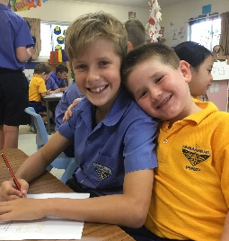
This week 6W joined Prep T for a fun filled afternoon of activities focusing on the letter F. The Year 6 students buddied with a Prep student to complete activities of making booklets which had poems inside beginning with the letter F. The Year 6 students then read the poems to the Prep students once they completed the booklet. They also drew and coloured frogs. The afternoon was thoroughly enjoyed by 6W and Prep T.
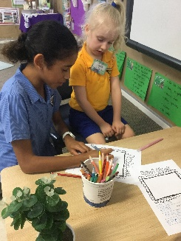
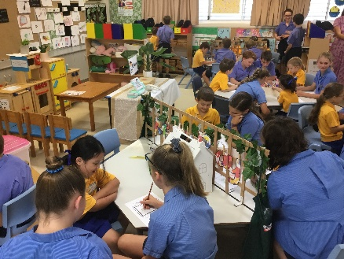

Janine Refalo
Assistant Principal Curriculum (Acting)

PREP ENROLMENTS - 2020
Prep enrolment details for 2020 are NOW required from our existing families. If you have a child due to commence Prep next year (born between 01 July, 2014 and 30 June, 2015) and already have children attending Emmanuel, please ensure that the enrolment form together with a copy of your child’s birth certificate, baptismal certificate and immunization record is returned to the school office by Friday 05 April, 2019. It is essential that we have our current families accounted for so as to determine how many positions may be offered to new families seeking enrolment. If you do not have an enrolment package please download one from the school website or collect one from the school office.

MATHS OLYMPIAD
Last week’s answer: 16
Question: At Greta’s Grocery Store, three bananas and two kiwifruit cost $2.30. Five bananas and six kiwifruit cost $4.90. What is the cost in dollar and cents, of four bananas and four kiwifruit?
STOP, DROP, GO
NO RIGHT TURN
IN OR OUT!!

THANK YOU
Last Friday’s school disco was a great success. A big thank you to Julie and Geoff Bagley for providing fencing free of charge. Also, thank you to our P & F, parent helpers and tuckshop helpers for cooking the BBQ and serving our students and parents.

Amanda McDonald
Assistant Principal Administration
Spotlight on Sports
INTERHOUSE ATHLETICS CARIVAL
Volunteers needed - In the past we have had many parents who have generously volunteered to help in many ways at the carnival. If you can help, please complete the slip at the bottom of this newsletter and return to the school. Alternatively, please email Mr Luke Dodson via Luke_Dodson@rok.catholic.edu.au

Luke Dodson
HPE Teacher

OPPORTUNITY TO LEARN THE VIOLIN
At Emmanuel we offer any interested students the opportunity to learn the Violin with Mrs Chelsea Jansen. Mrs Jansen has been teaching Violin at Emmanuel for the past 2 years and hopes to expand the string program with an intake of new students.

An expression of interest is extended to all students from Year 1 through to Year 6.

If you would like to enquire further about your child learning the Violin, please complete the expression of interest form (at the end of this newsletter) and submit to the Office by Friday 29 March, 2019.

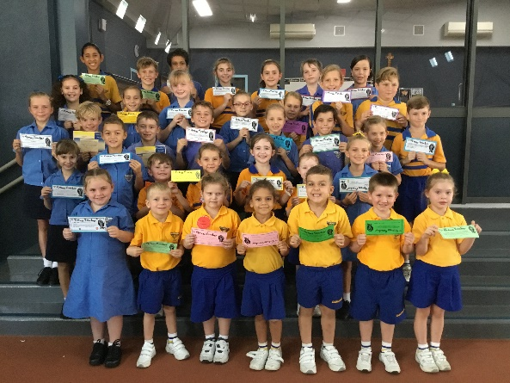

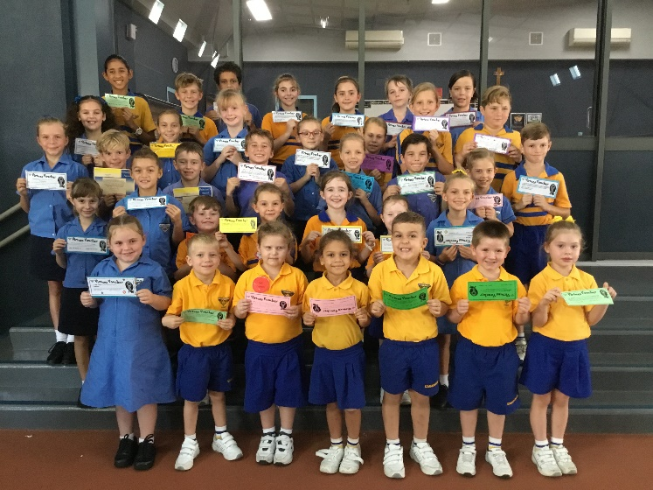

Tuckshop Roster – Week 9
Monday 25 Mar | Michelle Prince
Tuesday 26 Mar | Rachel Worth
Wednesday 27 Mar | Nicole Butler
Thursday 28 Mar | Nicci Lewis
Friday 29 Mar | Michelle Buckeridge  Katie Murphy
Thank You

OSCH
Community Notices
Prep | Ivy Muller  Leela Trannore  Archie Bittler | Oliver Schneider  Siale Hovinga  Oliver Sutton
Year 1 | Juliet Trannore  Savannah Dawes | Gabrielle McLean  Cooper Craig
Year 2 | Elise Doumergue  Talia Kirby  Charlee Byrne | Marlee Bobongie  Lacey Chivers  Hayley Chan
Year 3 | Laila Scott  Paige Illguth  Tanner Alloway | Jacob Deguara  Piper Armstrong
Year 4 | Hailee Slater  Hollie Hopson  Claire Marshall | Alex Webster  Bindert Hovinga
Year 5 | Masey Kelly  Tess Armstrong  Zane Armstrong | Alexus Hall  Madelyn Shepherd  Caitlin Diepeveen
Year 6 | Lily Ringelstein  Tanna Byrne  Caleb Byrne | Lachlan Doolan  Clara Chow

Virtue Vouchers
Important notice to families - A continuing issue is that families are having difficulty navigating the MyGov app to approve enrolments. This means that CCS will not be applied to their OSHC account, and they are effectively paying full fee. To assist, the government has supplied a guide (with pictures!) that you can send on to families by following this link:

https://www.humanservices.gov.au/individuals/online-help/centrelink/confirm-your-childs-enrolment-details-child-care-subsidy

If you are interested in enrolling your child at this service, our number is 0429 311 579 or email us at ENM_OSHC@rok.catholic.edu.au.

Lauren Gossweiler
Emmanuel OSHC Coordinator

School Disco

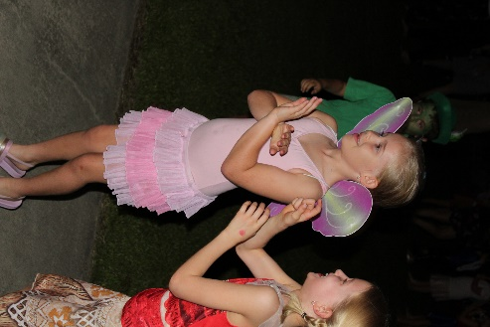
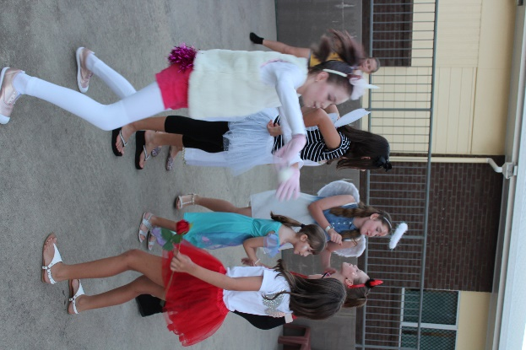
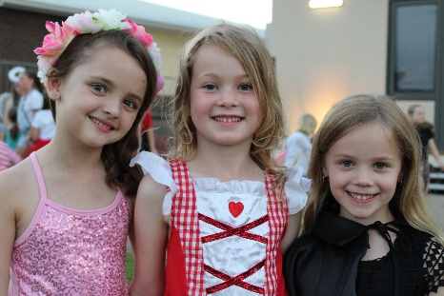

-----------------------------------------------------------------------------------------------------

ATHLETICS CARNIVAL HELPER’S NOTE

I can help on Friday 26 April at the Emmanuel full day athletics carnival.

Helper’s Name ___________________________________ Phone Contact ________________________

Child’s CLASS___________

I prefer to help with (please circle):

Scoring / Ribbon Writing / Timekeeping/ Judging / Marshalling / Ribbon Distributing / Anything / Setting up tents before and after carnival

-----------------------------------------------------------------------------------------------------
EXPRESSION OF INTEREST – Opportunity to Learn Violin

My child ___________________________ in Class ______ is interested in learning the violin.

Parent name: _________________________________ Contact : ____________________

